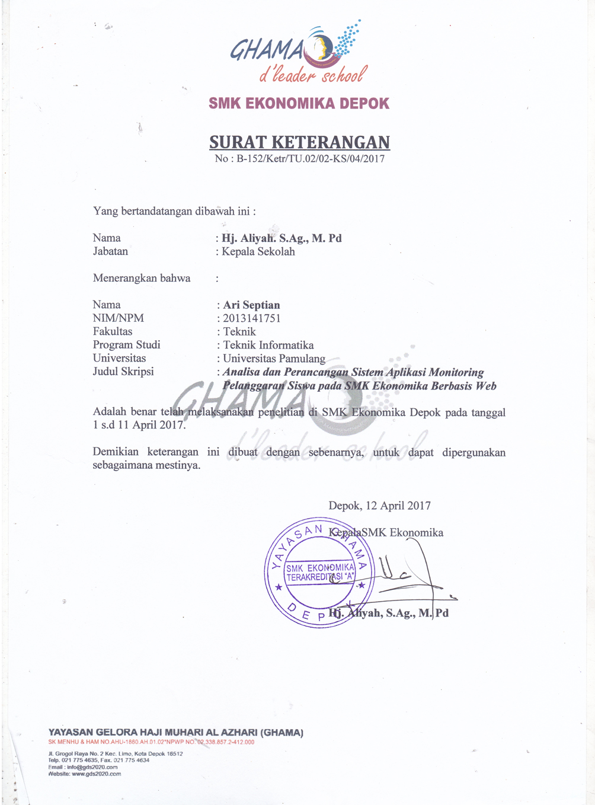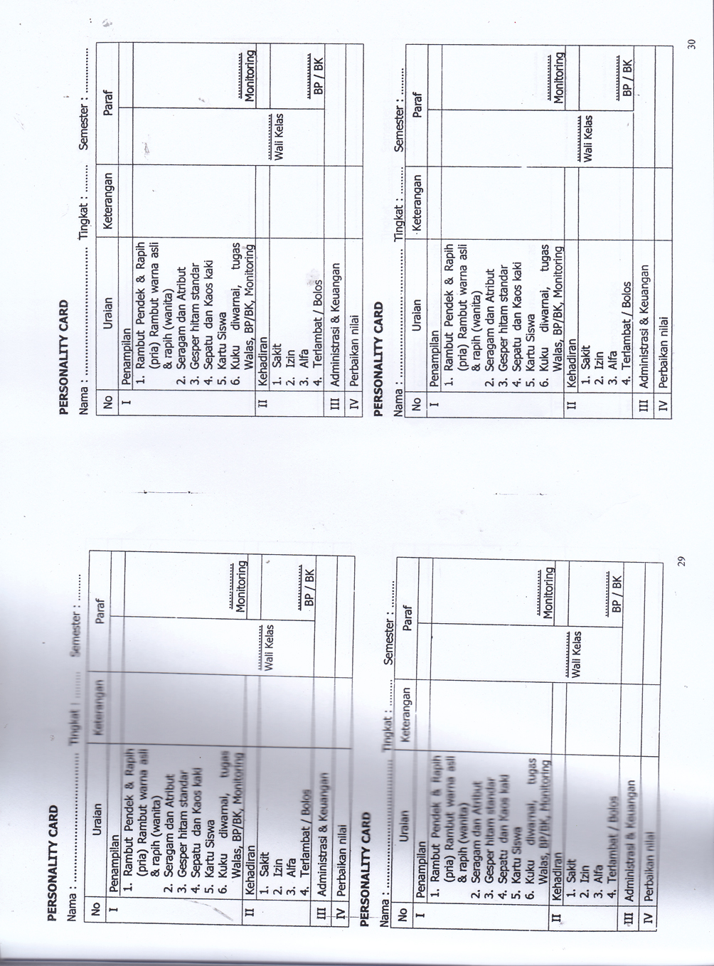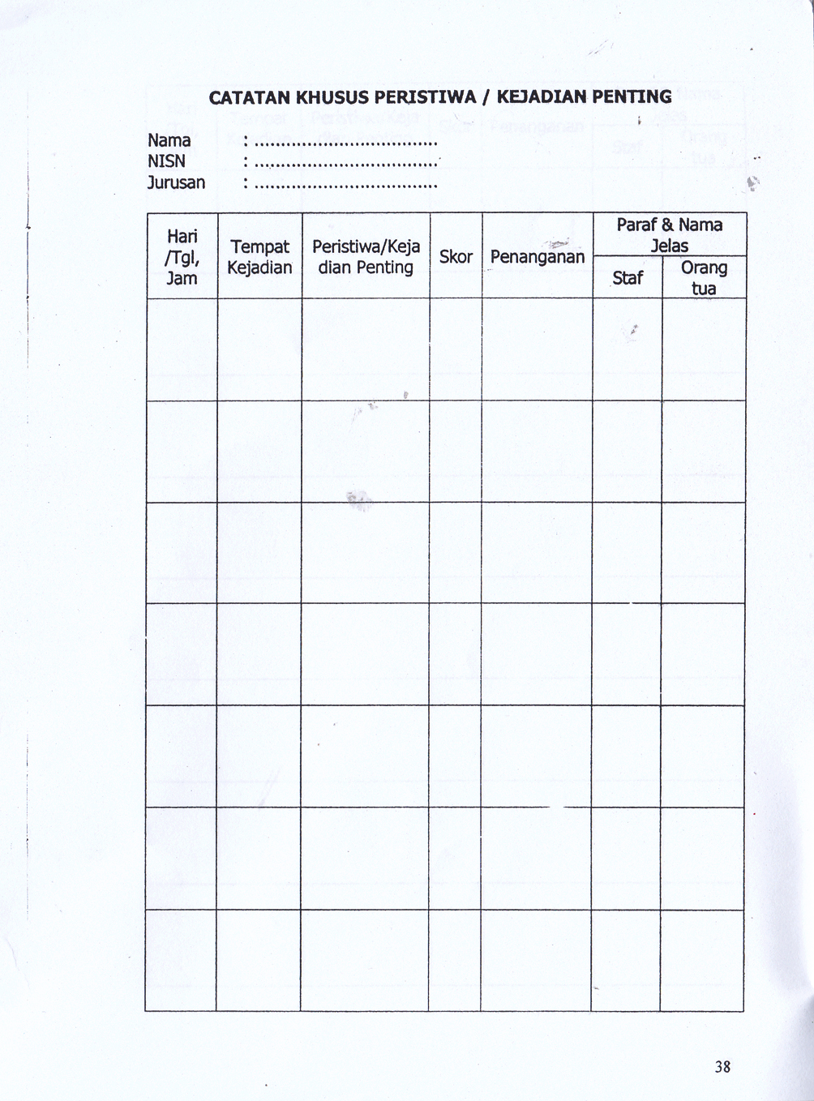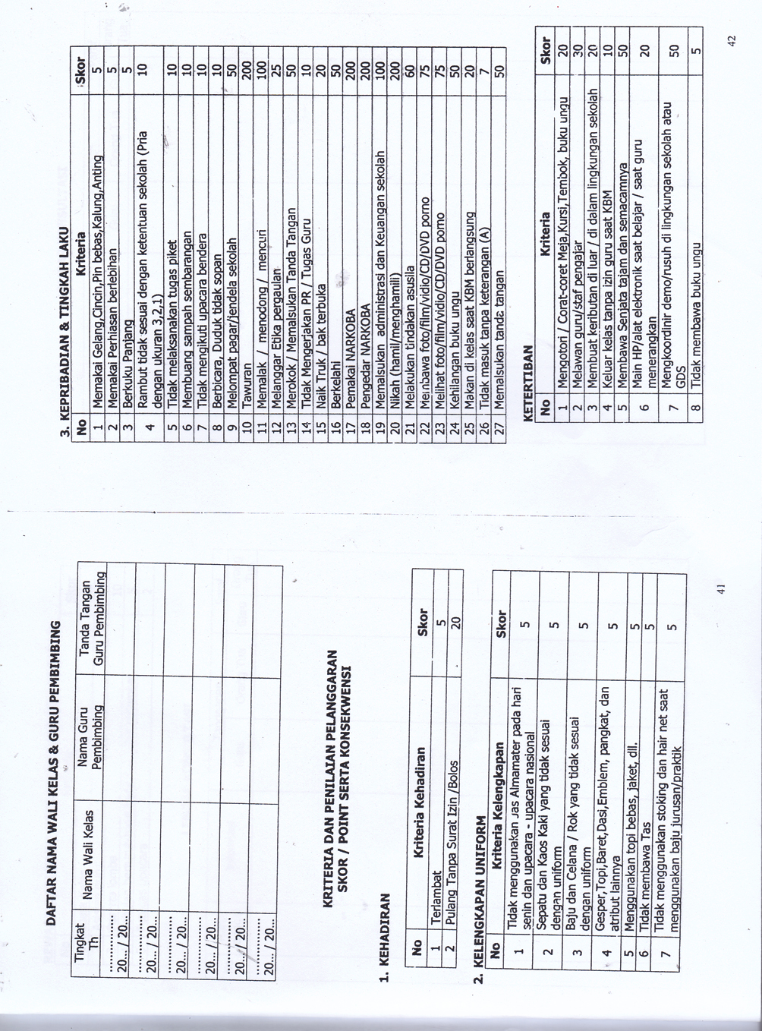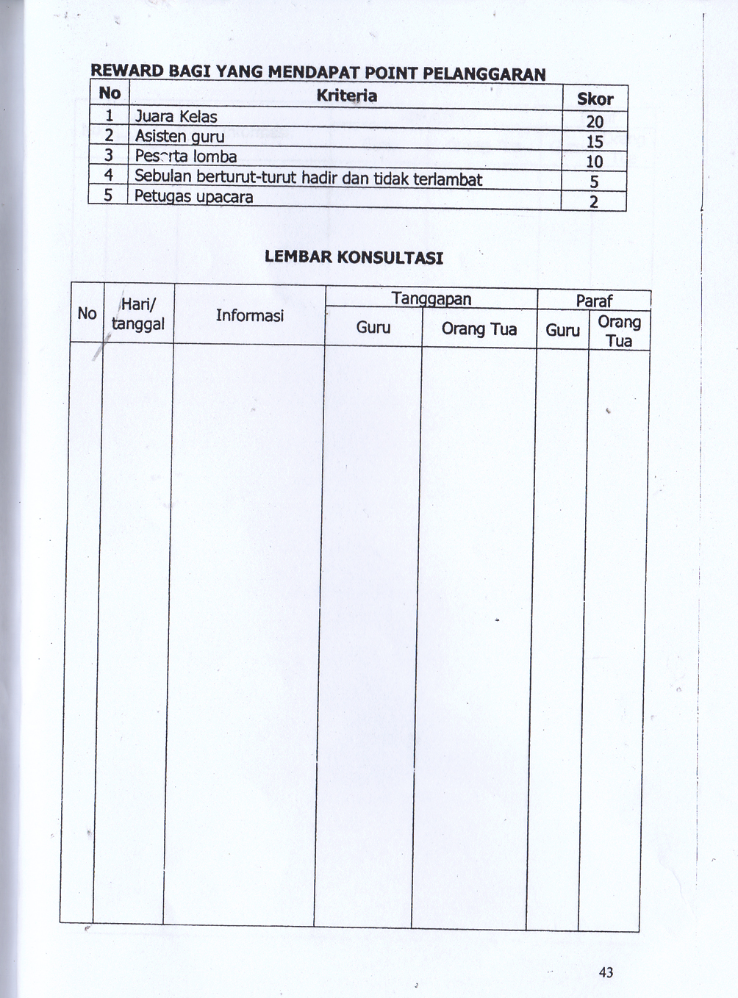

Data guru smk ekonomi
NO | NAMA GURU | MATA PELAJARAN
1 | Mardiana S.Pdi | Agama islam
2 | Abdul Alim S.Pdi | Agama Islam
3 | Ida Siti | Bahasa Sunda
4 | Pano Sanusi | Agama Islam
5 | Pdt Andreas | Agama kristen
6 | Karmila Dewi SH,M.Pd | PKN
7 | Suhasto,SH,MH | PKn
8 | Dahlia | B, Indonesia
9 | Eti Susanti,S.Pd | B, Indonesia
10 | Retno Sulistyo Rini, S.Pd | B, Indonesia
11 | Hamiah,S.Sos | Seni Budaya
12 | Nasir Roy | Seni Budaya
 | GURU BARU | Olah raga
13 | Guru Baru | Science club
14 | Jajang ,S.Hi | Public speaking
15 | SOMAJI,S.Pd | Penjaskes dan OR
16 | Endang Widi, S.Pd | English. Club
16 | Endang Widi, S.Pd | Convertation
17 | Endang Widi, S.Pd | B.Inggris
18 | Ana karolina, SS | B. Inggris
18 | Ana karolina, SS | E.Correspondence

Data siswa Smk Ekonomika
KELAS |  | : XI - LEADER
BULAN |  | :
NO | NIS | NAMA PESERTA DIDIK | L/P
1 | 15160001 | ANGGITA MEIDIANA SHAFIRA | P
2 | 15160002 | ANA MARIA | P
3 | 15160003 | ANNISA AZHARA | P
4 | 15160004 | FIRSTA SOFINAS SHOLIHA | P
5 | 15160005 | LAYLA NURKHASANAH | P
6 | 15160006 | NAZIA NUR IZZATUL ISLAM | P
7 | 15160007 | OKTATIANA | P
8 | 15160008 | RAFIKA DEWI SAFITRI | P
9 | 15160009 | SAFILA FARADIZA | P
10 | 15160010 | SEPTIA DWI CAHYANI | P
11 | 15160012 | SRI SUCI | P
12 | 15160118 | NERTA MARINA DINATA | P
13 | 15160013 | ALIEF VICKRY THAHA MAULIDZART | L
14 | 15160014 | DEBORA LEDY MEDA SILALAHI | P
15 | 15160015 | DELLA DELFIRA | P
16 | 15160016 | DEWINTA PRIMASHANTI | P
17 | 15160017 | ISMIYANTI SOLEHA | P
18 | 15160018 | LYDIA NUNIEK AGUSTINA UTOMO | P
19 | 15160019 | M. RIZKY WIDYANTO | L
20 | 15160020 | MUHAMMAD RIVALDI DWI PUTRA | L
21 | 15160021 | NAJWA NUR SAFFAANAH | P

