TEACHING VOCABULARY TO ELEMENTARY STUDENTS USING PICTURES
(A qualitative study in the second grade of SD Muslim Asia Afrika Kedaung –Pamulang)
A Thesis
Submitted in partial
Fulfillment of the requirements for the SarjanaSastra (SS)

ANIS ZULFAH
Reg.No : 2009060146
ENGLISH DEPARTMENT
FACULTY OF LETTERS
UNIVERSITY OF PAMULANG
PAMULANG
2016

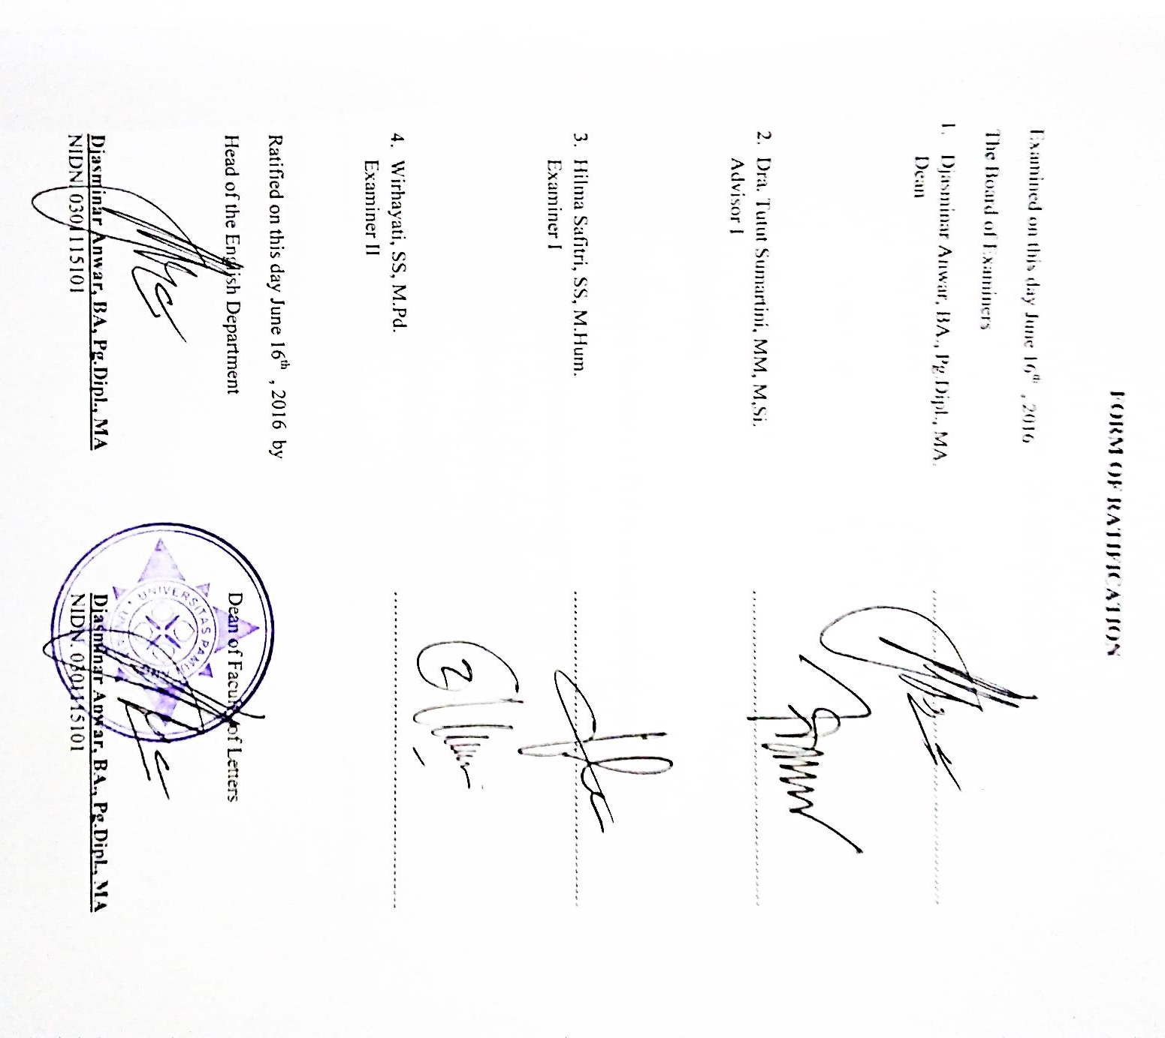

FORM OF STATEMENT

Name : Anis Zulfah
Reg. No : 2009060146
Study Program : English Department
Field : Teaching
Thesis title : Teaching Vocabulary To Elementary students Using Pictures (A Qualitative
Study in the second grade of SD Muslim Asia AfrikaKedaung – Pamulang).
Thesis Advisor I :Djasminar Anwar ,BA,Pg.Dipl,MA
Thesis Advisor II :TututSumartini,MM,M.Si
The mentioned above states “ This thesis is originally written by the writer and the contents of the thesis are fully the writer’s responsibility.

Tangerang Selatan, June 2016
The writer

Anis Zulfah
i
ABSTRACT
Mastering vocabulary in communication is very important .Vocabulary should be taught to students in good and interesting ways. Many techniques of teaching vocabulary have been taught by teacher . In this study, the writer observes the teacher’s way to teach vocabulary using pictures at SD Muslim Asia AfrikaKedaung-Pamulang and the results are very satisfying. She taught them used very interesting way, she used some pictures from books as media in teaching vocabulary to students.. The data collected was later described by the qualitative approach inside of this thesis. The data is explained in paragraph form. The result of the study concluded that during the learning process of the students showed an excellent response. Students of SD Muslim Asia Afrika followed the learning process well. They Using the methods and techniques above, they could apply their vocabulary in daily communication, it can also be showed from the vocabulary test results obtained by the students.

Key words :Vocabulary, Teaching, Pictures.

ii
ABSTRAK
Menguasai kosa kata dalam berkomunikasi sangat penting.Jadi, kosa kata harus di ajarkan kepada siswa dengan cara yang baik dan menarik. Ada banyak cara dalam mengajarkan kosa kata. Dalam penelitian ini, penulis mengobservasi cara guru dalam mengajarkan kosa kata menggunakan gambar, di SD Muslim Asia Afrika Kedaung – Pamulang, dan hasilnya sangat memuaskan. Guru tersebut mengajarkan murid – muridnya menggunakan cara yang menarik, dia menggunakan beberapa gambar sebagai media dalam mengajarkan kosa kata..Data yang di kumpulkan di gambarkan dengan pendekatan kualitatif seperti yang ada di dalam skripsi ini.Yaitu data yang di jelaskan dalam bentuk paragraf. Hasil penelitian di simpulkan sejak dalam proses belajar. Para siswa menunjukkan respon yang sangat baik. Siswa SD Muslim Asia Afrika Kedaung-Pamulang mengikuti proses belajar dengan baik. Mereka menggunakan teknik yang sudah di sebutkan di atas, mereka bisa mengaplikasikan kosakata mereka di dalam komunikasi harian mereka, hal itu bisa di tunjukkan dari hasil tes yang di jalankan oleh para siswa.

Kata kunci : kosakata, mengajar, gambar

iii
ACKNOWLEDGEMENTS

In the name of Allah the most merciful and the most compassionate.
Praise and glory to Allah Swt, the most merciful, the most compassionate, the lord of the world, for blessing the writer with great power, guidance and healt so that she able to finish this thesis. May sholawat and salutation always be given to the last and great prophet Muhammad SAW.
The writer will not able to finish this paper without any help given by advisor and people who have supported her and she realized that writing this study is not an easy work to do, it can not be finished without their help and support. In this opportunity, the writer would like to express her special gratitude to her beloved husband, daughter also her mother who always give their love and support so that she able to finished this thesis. The writer also like to address her gratitude and appreciate to the following :
- Drs. H. Darsono – The Head of Sasmita Foundation.
- Dr. H. Dayat Hidayat, M.M – Rector of Pamulang University.
- Djasminar Anwar,BA,Pg,MA – The Dean of Faculty of Letters, The Head of English Department and also as the writer’s first advisor. Her guidance and unfailing support has been a valuable motivation for the writer.
- Mrs.Tutut Sumartini who has guided and advised the writer during the course of this study.
- The lecturers of Faculty of Letters.
iv
- English teachers of SD Muslim Asia Afrika Kedaung – Pamulang.
- Murnalisa Yuliet,S.Ag as teacher the second grade of SD Muslim Asia Afrika Kedaung – Pamulang.
- Diana Sari, Azizah, Agi, Uci, Ida, Diah are my best friends.
- Bayu and saiful are my brothers, they always support the writer to continue this study.
Finally, the writer realizes that this study still has some weaknesses and mistakes. Therefore, the writer would like to accept any constructive suggestion to make this study better.
Tangerang Selatan, June 2016
The writer

Anis Zulfah

v
TABLE OF CONTENTS

Pages
FORM OF RATIFICATION
FORM OF STATEMENT………………………………………………………………………i
ABSTRACT..................................................................................................................................ii
ABSTRAK……………………………………………………………………………………….iii
ACKNOWLEDGEMENTS……………………………………………..……………………...iv
TABLE OF CONTENT…………………………………………………………………………v
.PREFACE……………………………………………………………………………………….ix
CHAPTER I INTRODUCTION
1.1 Background of the Study……………………………………………………………………1
1.2 Statements of the Problem…………………………………………………………………..5
1.3 Scope and limitation of the Study………………………………………………………….5
1.4 Goals of the Research………………………………………………………………………5
1.5 Function of the Research…………………………………………………………………..6
1.6 Systematical Presentation………………………………………………………………….6
CHAPTER II RELATED STUDIES, REVIEW OF LITERATURE
AND THEORETICAL FRAMEWORK
2.1 Related Studies……………………………………………………………………………..7
2.2 Review of Literature…………………………………………………………….………….9
vi
2.2.1 Vocabulary………………………………………………………………………9
2.2.2 Teaching Vocabulary for Children……………………………………………..10
2.2.3 Some Examples of Vocabulary with Picture……………………………………11
2.2.4 Method in Teaching vocabulary…………………….………………………..…15
2.3 Theoretical Frameworks………………………………………………………..….16
2.3.1 The Definition of Vocabulary.……………………………………………….….17
2.3.2 The Use of Vocabulary…………………………………………………….……18
2.3.3 Kind of Vocabulary………………………………………………………….…19
2.3.4 Practicing Vocabulary……………………………………………………….….20
2.4 The Definition of Picture …………………………………………………………21
2.4.1 The Type of Picture……………………………………………………………22
2.4.2 The Criteria of Good Picture…………………………………………………...24
2.4.3 The Significant of Picture In Teaching Vocabulary……………………………25
CHAPTER III RESEARCH METHODOLOGY
3.1 Approach of The Study……………………………………………………………26
3.2 Data Source ……………………………………………………………………….27
3.3 Techniques of Collecting Data…………………………………………………….28
3.4 Techniques of Data Analysis……………………………………………………...29
CHAPTER IV FINDING AND ANALYSIS
  - Research role……...……………………………………………………..30
vii
4.2 Classroom Observation Data……………………………………………………………31
4.3 The Result of Observation ……………………………………………………………..41
CHAPTER V CONCLUSION AND SUGGESTION
5.1 Conclusion………………………………………………………………………………46
5.2 Suggestion……………………………………………………………………………….47
BIBLIOGRAPHY…………………………………………………………………………..48
APPENDIXES

Viii
PREFACE

Recently there are many methods or techniques in teaching languages to help children improve their vocabulary especially in the classroom. All the methods offer many advantages to help children enjoy and like to learn English. The teachers apply visual aids in the classroom in order to make their students be able to improve their vocabulary more easily. One of the aids is by using pictures for teaching vocabulary.
In this thesis the writer elaborated the function of picture for teaching vocabulary, the advantages and effectiveness of using pictures for teaching vocabulary, the criteria of good pictures for teaching vocabulary and many more. The writer hopes that this thesis will be beneficial to the English teachers especially and to the readers generally.
The writer realizes that this thesis is still far from perfect, therefore she expects some developing criticism and suggestions to make this thesis better.

Pamulang, June 14, 2016
The writer

ANIS ZULFAH
ix

